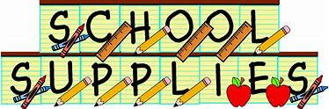

􀀀* #2 pencils with erasers (needs to replenished)
􀀀 * colored pencils (small pack)
􀀀 *highlighters – 2 different colors
􀀀 *multiple colored pens
􀀀 *Markers
􀀀 *scissors
*5 Duo-tang plastic pocket folders (3 prong)
*1 green, 1 yellow, 1 red, 1 purple, 1 blue
* 4 dry erase markers – NOT RED (low odor)
*1 ½” binder to hold agenda book, homework folder, and calendar
* Eraser for dry erase board (socks, wash cloths, Mr. Clean Magic Eraser, whiteboard eraser)
* pouch to keep supplies in (no boxes please)
􀀀* Clear protractor, and ruler (customary and metric)
􀀀 *6 -100 page composition books (may need to be replenished 2nd semester)
􀀀 *Headphones or ear buds (to be kept at school)
􀀀 * Boys – 1 container antibacterial wipes
􀀀 *Girls - quart Ziploc bags
􀀀 * At least 20 glue sticks (10 first semester/10 second semester)
􀀀 * 1 cube 3” Post-It notes
􀀀 * regular box of tissues
􀀀*Boys – one pack of lined paper (wide-rule)
􀀀*Girls – one pack of white printer paper
􀀀* $25.00 donation FL ELA Performance Coach and Storyworks

